**Logging using SLF4J**

**Exercise 1: Logging Error Messages and Warning Levels Task:**

Write a Java application that demonstrates logging error messages and warning levels using SLF4J.

Step-by-Step Solution: 1. Add SLF4J and Logback dependencies to your `pom.xml` file: org.slf4j slf4j-api 1.7.30 ch.qos.logback logback-classic 1.2.3

2. Create a Java class that uses SLF4J for logging:

import org.slf4j.Logger;

import org.slf4j.LoggerFactory;

public class LoggingExample { private static final Logger logger = LoggerFactory.getLogger(LoggingExample.class);

public static void main(String[] args) {

logger.error("This is an error message");

logger.warn("This is a warning message");

}

package com.Spring2.mySpringProject2;  
  
import org.slf4j.Logger;  
import org.slf4j.LoggerFactory;  
  
public class LoggingExample {  
  
 private static final Logger *logger* = LoggerFactory.*getLogger*(LoggingExample.class);  
  
 public static void main(String[] args) {  
 *logger*.error("This is an error message");  
 *logger*.warn("This is a warning message");  
 }  
}

}

<dependency>  
 <groupId>org.slf4j</groupId>  
 <artifactId>slf4j-api</artifactId>  
 <version>1.7.30</version>  
</dependency>  
  
<!-- Logback (SLF4J implementation) -->  
<dependency>  
 <groupId>ch.qos.logback</groupId>  
 <artifactId>logback-classic</artifactId>  
 <version>1.2.3</version>  
</dependency>  
  
<dependency>  
  
 <groupId>org.slf4j</groupId>  
 <artifactId>slf4j-api</artifactId>  
 <version>2.1.0-alpha1</version>  
  
</dependency>

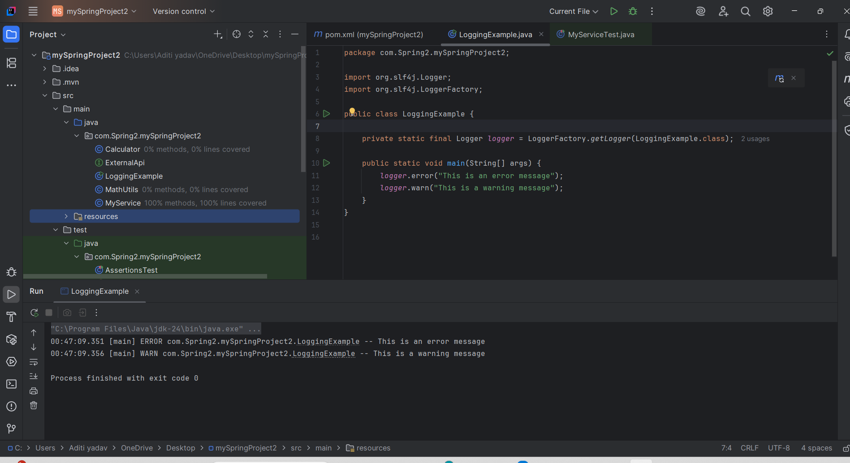

**Exercise 2: Parameterized Logging Task:**

Write a Java application that demonstrates parameterized logging using SLF4J.

Step-by-Step Solution:

1. Add SLF4J and Logback dependencies to your `pom.xml` file: org.slf4j slf4j-api 1.7.30 ch.qos.logback logback-classic 1.2.3

2. Create a Java class that uses SLF4J for parameterized logging:

Write code for this.

Code:

package com.Spring2.mySpringProject2;  
  
import org.slf4j.Logger;  
import org.slf4j.LoggerFactory;  
  
public class ParameterizedLoggingExample {  
 private static final Logger *logger* = LoggerFactory.*getLogger*(ParameterizedLoggingExample.class);  
  
 public static void main(String[] args) {  
 String username = "aditi";  
 int userId = 101;  
  
 *logger*.info("User {} with ID {} has logged in.", username, userId);  
  
 String error = "File not found";  
 String path = "/user/data/file.txt";  
 *logger*.error("An error occurred: {} at path: {}", error, path);  
 }  
}

